# EEGpal: **Interpolation module**

Version 1.0, 16.02.2025

Interpolation' is used to remove bad electrodes/channels by replacing them with an estimate of how the signal should be using other neighboring channels. The user can choose between two different algorithms to perform this interpolation.

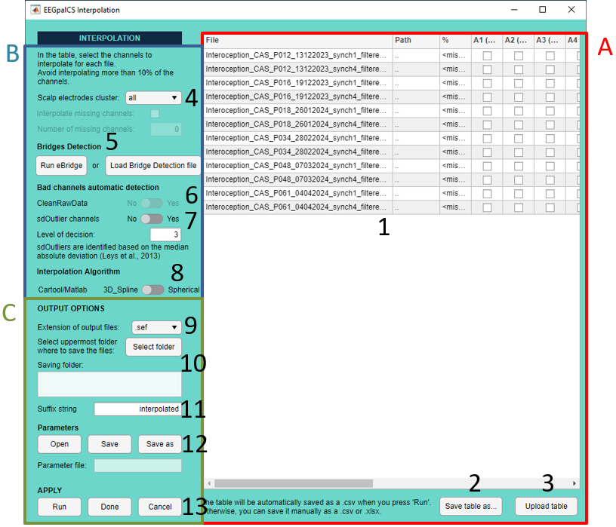

Pannel A:

1. This table lists all the files and electrodes. You can manually tick or untick the channel you want to interpolate. However, we advise you to first save the table (point **2**), complete it in Excel and upload the new table (point **3**), which is much easier (see FAQ **How to determine which electrodes to interpolate?**). The % column automatically indicates the percentage of the electrode to be interpolated for each file. As a general rule, try to avoid interpolating more than 10% per file.
2. Save the table as ‘.csv’ or ‘.xlsx’ file. It would be much easier to work on it in Excel
3. Upload the ‘.csv’ or ‘.xlsx’ after filling it

Pannel B:

1. If you defined scalp electrode cluster. *Usually not used*.
2. Bridge Detection: A bridge is when two channel are connected (usually due to gel contact) and they record the same signal. It is something we don’t want and these channels need to be interpolated. Here you have the choice:
   1. Run the eBridge script
   2. If you have already run the eBridge script from the EEGpal main window (necessary if you performed an ICA), you can directly load its .xlsx output file

Both options will automatically fill the interpolation table (**1**) with bridged channels.

1. Enable or disable the suggestion of bad electrodes made by CleanRawData. This option is only available if the interpolation module detects that you have activated the **Flag bad channels** option in the Clean Rawdata panel of the **Filtration+** module. These bad channels could be added here in the interpolation table (Yes) or not (No).  
   Note from the EEGpal authors: we advise you not to use this option as we are not convinced by the results (see in FAQ **ow to determine which electrodes to interpolate?)**.
2. This is another automatic detection based on the median absolute deviation from (Leys et al., 2013).  
   As for the previous option, the EEGpal authors advise to not use this option as we are not convinced by the results
3. Here you can choose between two interpolation Algorithm:
   1. 3D_Spline is the method used by the Cartool software. It is based on the article: *Perrin, Pernier, Bertrand, and Echallier (1989). PubMed #2464490*.
   2. Spherical is the default method used by eeglab

See FAQ for more details

Pannel D

1. Select the format for the output files.
2. Select the destination folder where the results files will be saved (note: it reproduces the input structure. For example, a folder per participants if the input files where in subfolder).
3. The suffix added to the input filename to obtain the output filename
4. You can save a parameters file which will recode all the chosen options for a later processing (**save** and **save as**). You can use the button **open** to call a previous saved parameters file.
5. Click on **Run** to carry out the processing parameterized. The button **Done** will close the module without perform the processing but keep in memory your parameters if you open it again. The button **Cancel** closes the module without processing and without keep the entered parameters in memory.

FAQ

**How to determine which electrodes to interpolate?**

The choice of which electrode to interpolate is largely user-dependent, making this step the most difficult point in the EEG pre-processing pipeline. People have tried to implement automatic way to perfom it but the results are disappointing (as see in point **X**). The best method reminds the visual inspection by the experimenter. I will here explain my way to performed this step but I don’t claim that it is the best way. We are going to use the Cartool software for the visualization of our data (<https://cartool.cibm.ch/download/>).

Before to start, I would first open the Interpolation module dans perform the following steps:

1. Enter the bridged channels (see point **X**) either by Run eBridge with the “Run eBridge” button or with “Load Bridge Detection file” if you already performed a eBrige check
2. Press on the “Save Table as” to save the table on your hard drive (see point **X**)
3. Open the file with Excel. Use the tool “Data->Text To colums -> Delimited by comma” to format the file in columns.   
   A screenshot of a computer

   Description automatically generated
4. This file will be your decision file about the channels to interpolate. Leave 0 to keep a channel and put 1 when you want to interpolate it. If you want to have an automatic calculation of the % of channel rejection, insert the following formula in cell C2: =(SUM(D2:BO2)/COUNT(D2:BO2))*100 (this formula is for a 64-electrode configuration, but must be adjusted if you use a different number of electrodes) and then copy/past it in all cell of the third column (column C).

Remember that you can interpolation maximum 10% of signal (so 6 electrodes for a 64 EEG cap)

1. Save As the file into *.xlsx format to work in it.

Now there are two main cases which conduct to two different strategies:

Case 1: Evoked-related potential study (ERP study).

In order to make our life easier, we are going to perform a temporarelly Epoching to create ERP files with the actual file. Please refer yourself to the Epoching module manual to generate **within-subject** averaged files **Per trigger**.

Now you will inspect the ERP to detect potential bad channels after averaging.

1. Open Cartool
2. Create a link any file (.lm) and drap_and_drop the electrode file 64-Biosemi_Oval_DePretto.xyz” inside of the Resources sub-folder of EEGpal folder. Save it at a place easey to access because you will open it seral times.A screen shot of a computer

   Description automatically generated
3. Visualisation:
   1. Drap and drop an ERP file into the lm file  
      A screenshot of a computer

      Description automatically generated
   2. Press on the topography windows, then 1x ,then 1x, then 1x
   3. Press on the electrode windows, then 2x
4. **Test visually** **the topography**
   1. Put the cursor at the origin
   2. Move the cursor with the keyboard right arrow and look carefully at the change of topography. You are looking if the electric charge of an electrode is incoherent with the neighbor electrodes during a stable period of time (and not at the ERP end). For example (see the picture below), the electrode highlight by the red rectangle has an abnormal polarity stable in time = electrode to interpolate  
      A screenshot of a game

      Description automatically generated
5. **test visually on the eeg-track**
   1. Click on the electrode window
   2. With the keyboard, press *on “SHIFT” + “-“* keys, then press 5x on *“+”* to see only 5 electrodes on the screen
   3. With the keyboard, press on *“CTRL” + “↑”* key to increase the amplitude (make the comparison easier)
   4. Change the channels on the screen with *“↑”* and *“↓”* key. Carefully look the trace of electrodes. If there is a weird electrode in comparison to **SPATIAL** neighbors (huge difference of oscillations) = electrode to interpolate.   
       For example (see the picture below), B12 is odd comparing to its direct special neighbors.

* 1. Further tools to help decide whether a chanell needs to be interpolated or not:
* Select the channel you are insecure about with the middle button of the mouse and go to Selection > Keep current selection  
  Ein Bild, das Text, Screenshot, Diagramm, Karte enthält.

  Automatisch generierte BeschreibungEin Bild, das Text, Software, Screenshot, Multimedia-Software enthält.

  Automatisch generierte Beschreibung
* Only the selected ones are presented and you can see the channel within its neighbours instead of only within the numerical order. Then press the “S” on the keyboard to stack the channels, to look at potential effects of higher amplitude/threshold changes

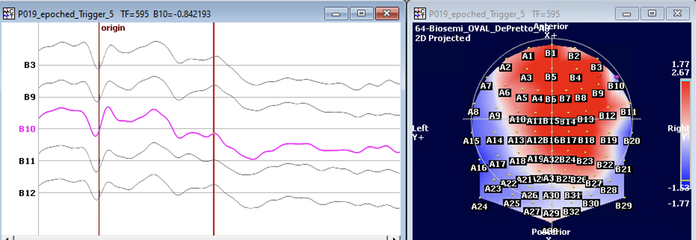 Ein Bild, das Text, Reihe, Diagramm, Screenshot enthält.

1. Close the .lm file and reopen the .lm you saved in step b. Repeat this steps **c** to **e** with other ERP file of the same participant.  
   Take the decision about which electrode you detected you will actually interpolate and fill the interpolation file according to your choice. Do forget the following rules for your decision:
   1. Max 10% of electrodes per participant to interpolate. If you really need to have more, consider the participant as an outlier.
   2. interpolate the SAME channels across one participant
   3. Then bridged channel detect need absolutely to be interpolated
   4. Then the possible noisy electrodes you have notice in point d (topography) and f (electrode trace). If two neighbors are bad, interpolate only one of them (preference to the electrode which is not on the border of the hat).
2. Fill the interpolation file with your choices and saved it (keep the .xlsx format)

Case 2: Non-ERP study like Resting state

In this case, you cannot perform a temporarily Epoching to help you. You have to look at the raw signal.

Look at the channels visually. Hereby only note the CLEARLY bad channels.

Example of bad channels:

* 1. Electrodes with continuous oscillation different from neighbours

* 1. Regular spike which means that it is a technical artefact and not a physiological signal  
     A graph of a graph

     Description automatically generated
  2. A single channel with abnormal high amplitude different from neighbours during a long time period  
     A graph of a graph

     Description automatically generated with medium confidence

Look at technical artefact and not to transitory movement of the participant. If you notice such channels, note it!

Section written by Michael Mouthon, FNDlab, University of Fribourg

**Which functions are used to perform the Interpolation?**

As explained in point **8**, there is two possible algorithms to perform the interpolation:

1. For the 3D_spline (based *Perrin, Pernier, Bertrand, and Echallier (1989). PubMed #2464490),* EEGpal used the function **interpolate_perrinX.m** written by Mike X Cohen which is available in the material associate to his book *Analyzing Neural Time Series Data: Theory and Practice* (MIT Press, 2014)  
   <https://direct.mit.edu/books/monograph/4013/Analyzing-Neural-Time-Series-DataTheory-and>
2. For the Spherical option, EEGpal use the eeglab function **pop_interp** developed by Arnaud Delorme, CERCO, CNRS, 2009.

**Which of these two solutions should I use?**

Regarding the choice of filtering method, the two options are fully validated. The authors have a preference for the 3D_Spline, which does not assume that the EEG electrode has a spherical coverage as the spherical method (because a human head is not spherical, but oval). However, the use of the eeglab version might be easier to argue with a reviewer.